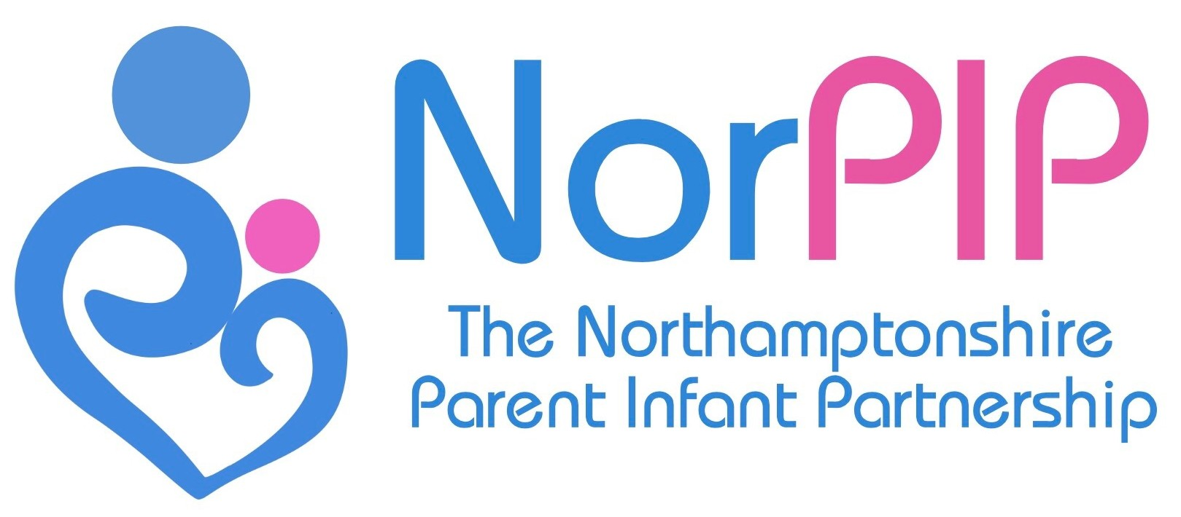
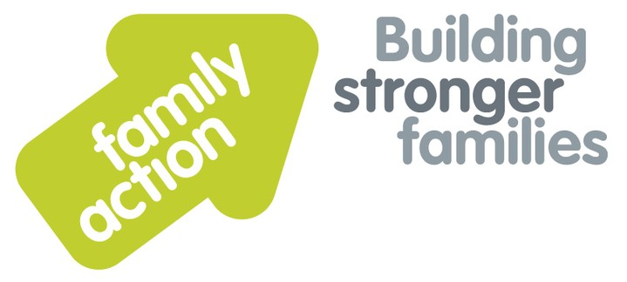
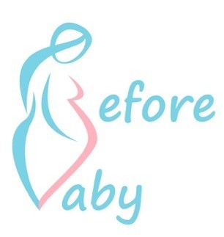
Referral Form
For Office Use Only
Date of Referral |  | Lead Worker
Referral Org. |  | Norpip Case No.
Area |  | Referral Code
Safeguarding status |  | Funder
Section A to be completed by the referrer
Requesting:(Please Tick): Parent Infant Psychotherapy Perinatal Support* Antenatal classes*
*=only available to families in NN1-NN5 and NN11

Family Information
Family Name:
Birth Mother’s Name: |  | D.O.B.:
Birth Father’s Name: |  | D.O.B.:
Baby’s name: |  | DOB/EDD:
Siblings: |  | DOB/ Ethnicity:
 |  | DOB/ Ethnicity:
 |  | DOB/ Ethnicity:
Family Address: |  | Mother Ethnicity:
 |  | Father Ethnicity:
 |  | Infant Ethnicity:
Others co-resident: |  | Other addresses:
Telephone/Mobile
Email / Social media |  |  | Preferred method of contact:

Professionals Information | Name | Contact Details
Midwife
Health Visitor
GP Surgery
Social Worker
Other

Child in Need | Child Protection Plan | Early Help Assessment | Looked After Child
Family on Benefits | Interpreter Required (Specify language):
Disability Access Requirements:

Clinical Information and Risk Factors

Infant Vulnerabilities
Failure to thrive / feeding concerns
Very Low birth weight / Premature
Diﬃcult infant temperament
Mother drank alcohol during pregnancy
Mother smoked during pregnancy
Prematurity
Congenital abnormalities / illness / serious developmental delay
Chronic maternal anxiety or stress during pregnancy

Parental Vulnerabilities and History | Mother | Father
Mental illness including anxiety or depression
Serious medical condition or disability
Learning diﬃculty or low educational achievement
Alcohol and/or substance misuse
Current domestic violence or abuse
Historical violence in the family
Significant bereavement
Poor or conflictual partner relationship between parents
Social isolation / lack of support structures
Chaotic lifestyle
Financial diﬃculties

Interaction and relationship Concerns | Mother | Father
Insensitive or inconsistent caregiving
Poor eye contact / avoidant infant behaviours
Lack of developmentally appropriate interactions
Caregiver does not enjoy the baby
Negative feelings towards the baby
Neglect or maltreatment (if yes please give details in referral)

Section B to be completed with the parent(s)

Current concerns:

Please note that NorPIP services are only available to vulnerable parents of an infant under the age of 2. NorPIP is not a universal service and therefore referrals may be refused if there is not a presenting need.
Summary of reasons for this referral
Current or previous interventions
How would you like your relationship with your baby to be different?

Referrer Details
Name: Signature:

Role: Telephone:

Date: Email:

Parental consent:

I confirm that I consent to being referred to this support service
or
I confirm on behalf of the parent that they have consented to this referral

Date

